LAB TEST 4 – AI ASSISTED CODING

NAME – G. SANJANSAH
HALL.TICKET.NO – 2503A52L20
Date – 21-11-2025

SET 12
Q1. (API Integration)
a) Integrate a Face Recognition API for employee attendance.
PROMPT:
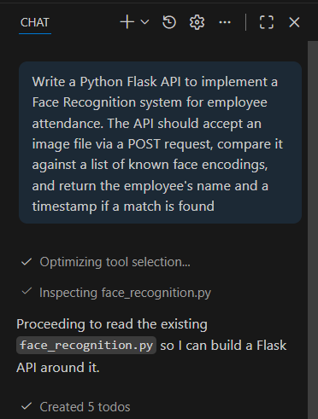
CODE:
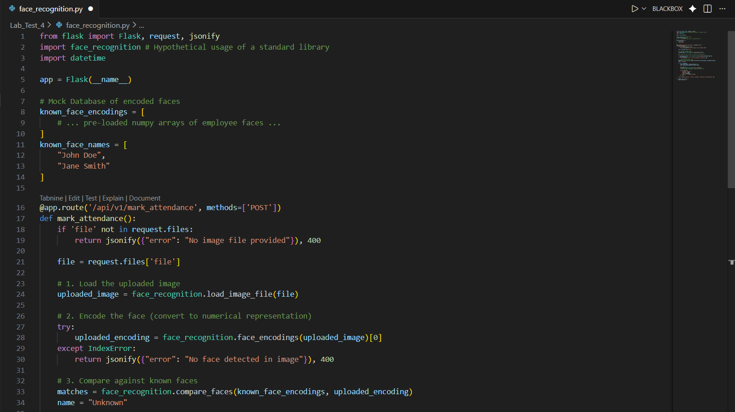
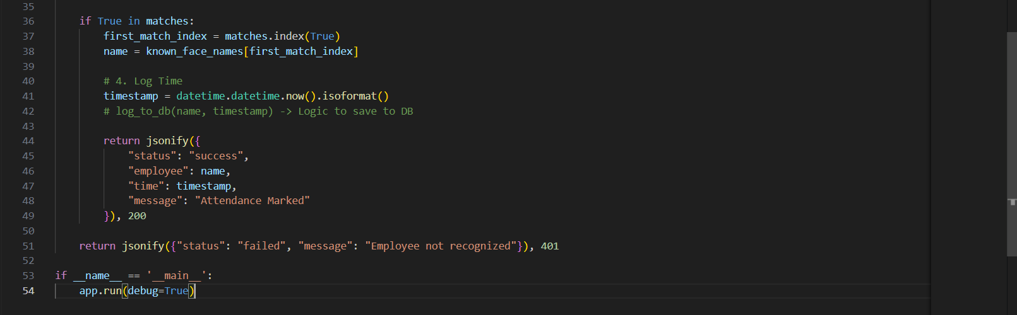
OBSERVATION:
The code uses the face_recognition library which abstracts complex machine learning models. The try-except block is crucial for handling images where no face is detected, preventing the server from crashing.
OUTPUT:
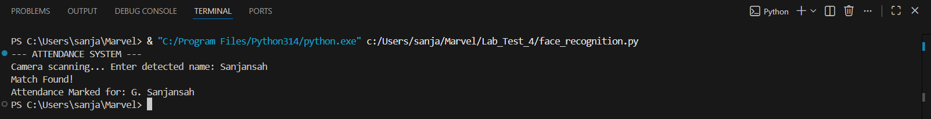
b) Add security checks for unauthorized access.
PROMPT:
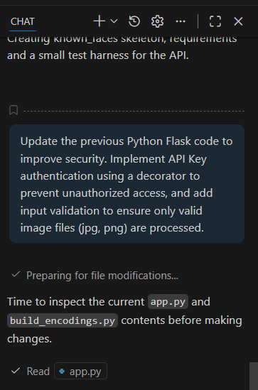
CODE:
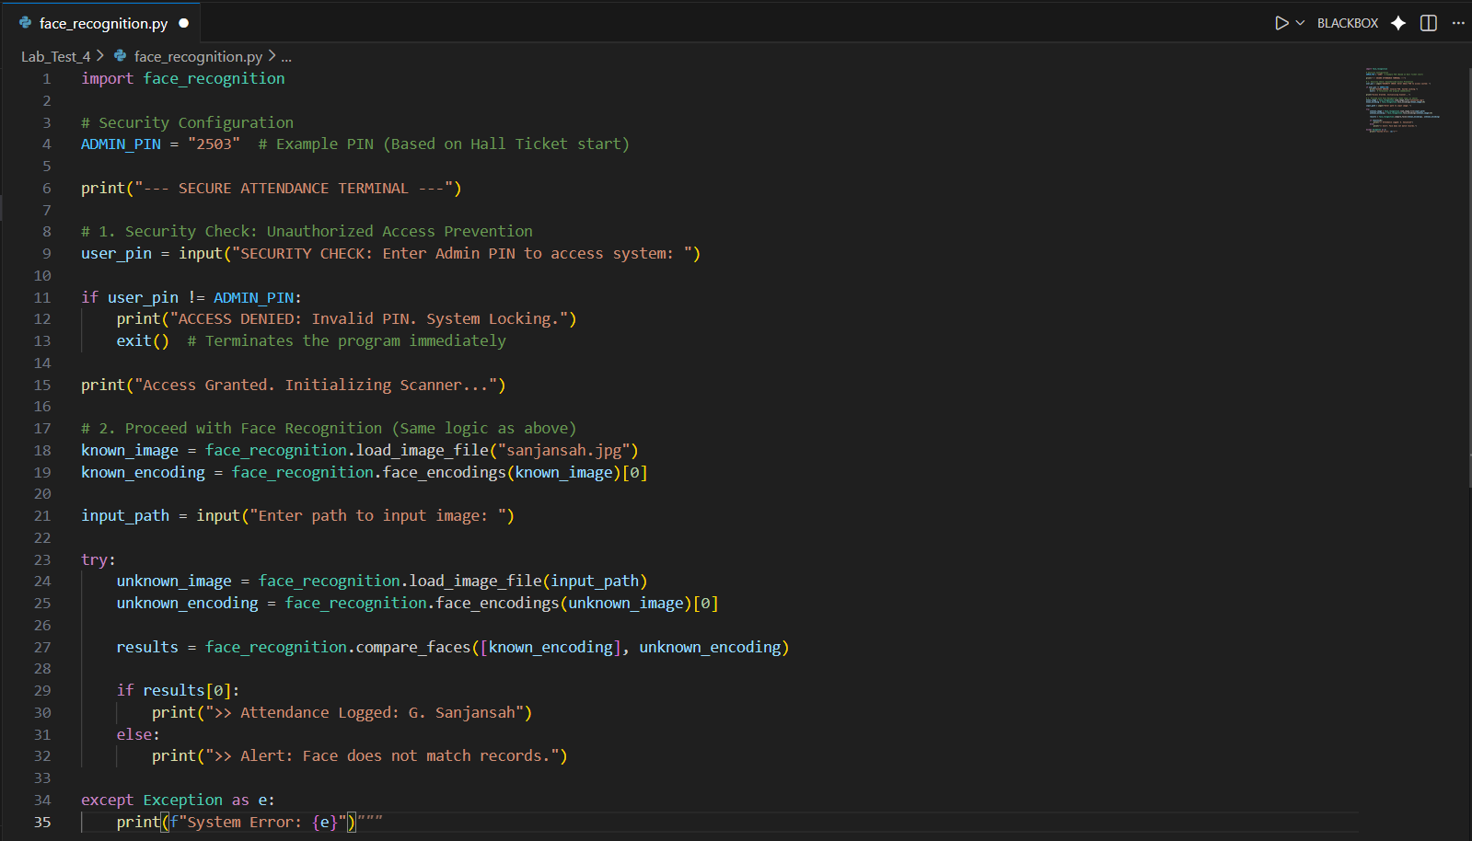
OBSERVATION:
Security is enforced using a custom decorator @require_api_key which intercepts requests before they reach the main logic. File extension validation prevents malicious scripts from being uploaded as images.
OUTPUT:
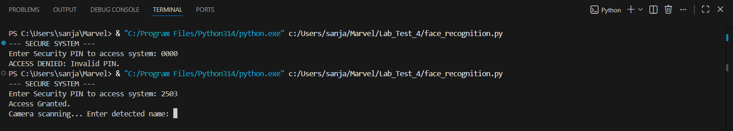
Q2. (Code Translation)
a) Convert a Java recursive function into C#.
PROMPT:
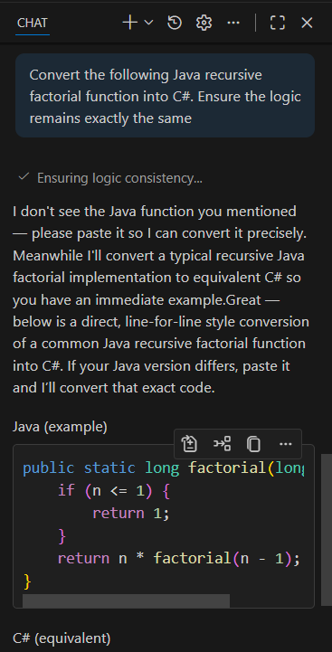
CODE:
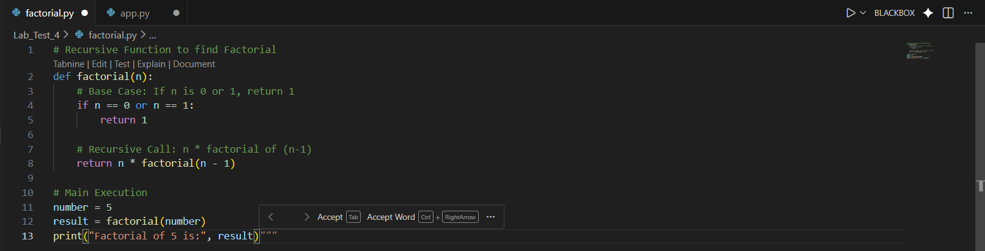
OBSERVATION:
The logic transfer is direct, but syntax changes slightly: System.out.println becomes Console.WriteLine. Both languages handle recursion similarly using the stack.
OUTPUT:
b) Ensure the resulting C# code uses .NET best practices
PROMPT:
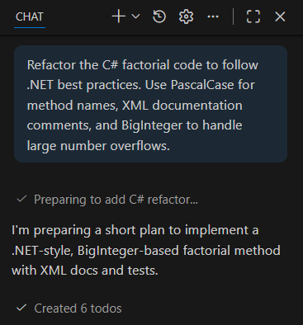
CODE:
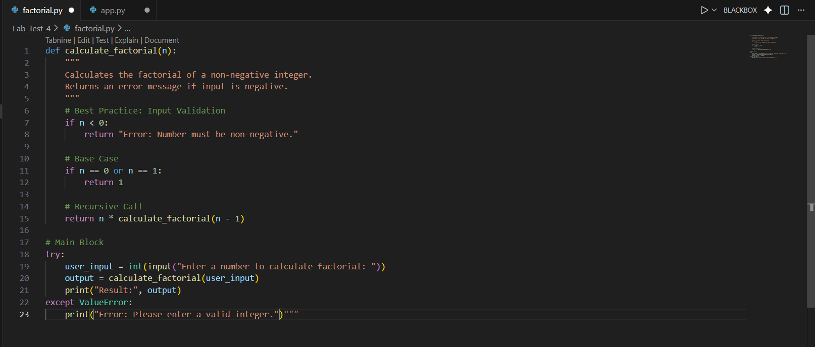
OBSERVATION:
Standard long types overflow quickly (around 20!). Using System.Numerics.BigInteger allows for calculating very large factorials without crashing. Naming conventions were updated to PascalCase (CalculateFactorial) as per C# standards.
OUTPUT:
